**Materials Data Curation System:**

**Setup instructions for Windows**

1. **Download and install MongoDB 3.x from** [**https://www.mongodb.org/downloads**](https://www.mongodb.org/downloads)
2. **Download and install Redis from** [**https://github.com/MSOpenTech/redis/releases**](https://github.com/MSOpenTech/redis/releases)
3. Make sure you have downloaded and installed MongoDB and Double-click on setup.exe.

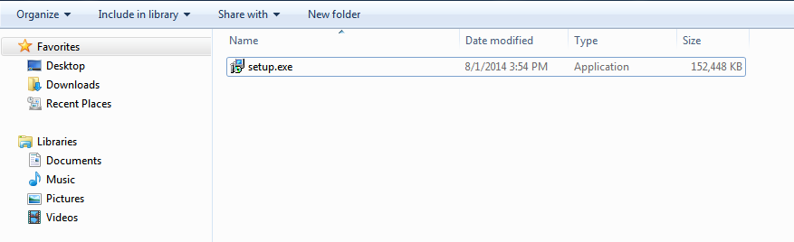

1. A pop-up asking for administrator access will appear. Allow the program to run on your computer by typing your username and password and click on ‘Yes’, or simply by clicking on ‘Allow’.
2. Use the setup assistant to install the program. Go to the next step using the ‘Next’ button. **If installed into ‘Program Files’, the program will have to be run with admin permissions (right click on the ‘mdcs’ shortcut and click on ‘run as an administrator’).**

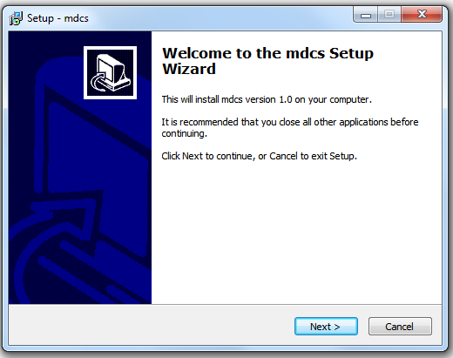

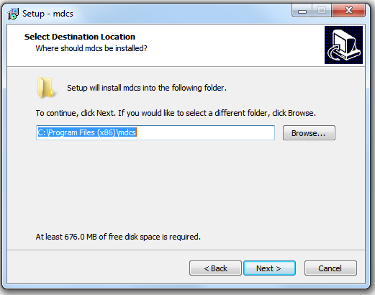

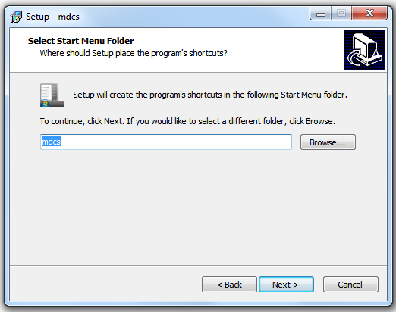

1. Then click on the ‘Install’ button to start the installation.

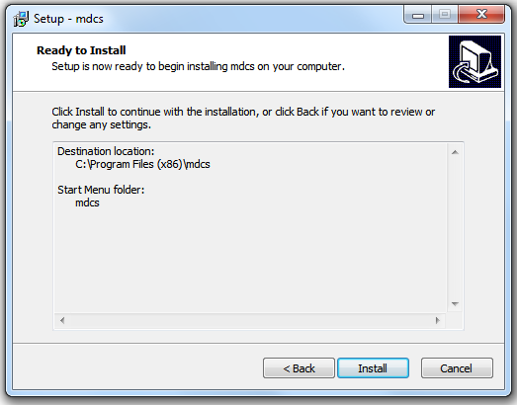

1. Wait for the installation process to finish.

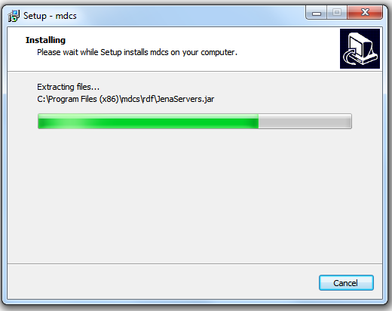

1. Click on Finish to close the setup assistant.

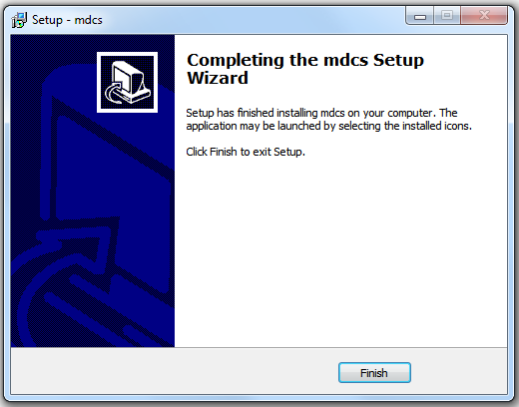

1. The program is now well installed on the computer and a shortcut is created on the desktop.

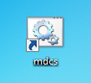

1. Once you click on the mdcs icon, a web browser will open and you will be able to start using the Curator.